Understanding the Login Process

Click on this link:
https://www.umassp.edu/connect

Scroll down the page and select

When you login to the HR Direct application, you will complete the following required fields: Campus User ID, Password, and Campus.

The Campus User ID is you network ID

The Password is the same password you use with your network account.

The Campus dropdown list is used to verify your account when you login to HR Direct, select President’s Office

Logging onto the HR Application

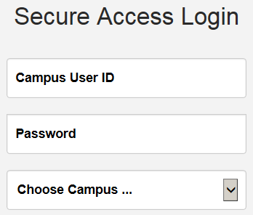

Click the Login in button

View Your Personal Information

Click on the “Personal Details” tile
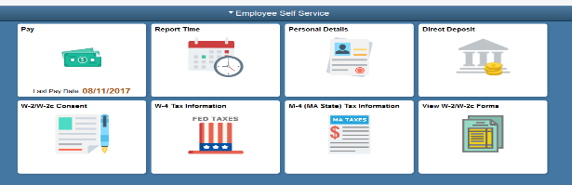
The Personal Information page opens.

- The personal information page will open where you can view addresses, contact details, ethnic groups, emergency contacts and additional information.

Edit Emergency Contacts

- Click on Personal Detail tile as noted above.
- Click the Emergency Contacts link.
The Emergency Contacts page opens.
- Click an existing contact to edit a contact.
- To delete a contact, click on the contact name, click delete button at bottom of the pop up window.
- To change a contact to preferred, click on the contact name and select preferred check box.
- Click the plus icon to add a new emergency contact. Then click the Save button. 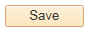

View Your Pay Advice

Click on the “Pay” tile
The Paychecks page opens.

- Click on a paycheck to view the paycheck.

- The Paycheck opens in a new window.

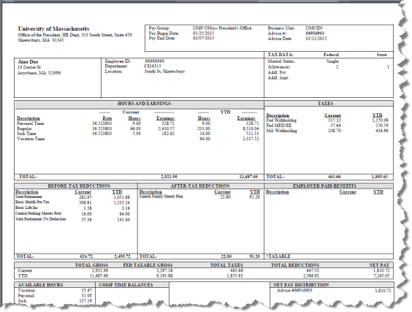

Updating W-4 Information

Click on the “W4 Tax Information” tile
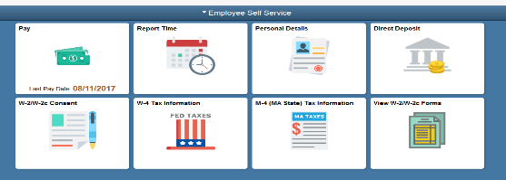

The W-4 Tax Information page opens.
- You have the option to change your exemptions, change additional amount withheld, change marital status or claim exempt.

Click the submit button

Updating M-4 (Mass State) Tax Information

Click on the “M4 (Mass State) Tax Information” tile

The M-4 Tax Information page opens.

- You have the option to change your exemptions, change select additional tax status or claim exempt.

Click the submit button

Enrolling in Direct Deposit

Click on the “Direct Deposit” tile
The Direct Deposit page opens.

- To add an account, click the Add Account button. If you already have an account, you will need to enter that account number, if not, you will not be asked for an account number.

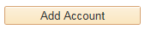

- Enter the desired information into the Routing Number field. Enter a valid value e.g. "011000138".
- Enter the desired information into the Account Number field.
Enter a valid value e.g. "12345678".
- Use the Account Type field to select the type of account you will now be adding.
- Use the Deposit Type field to specify whether you would like to deposit a flat amount, a percentage, or the balance of your pay. If you are setting up only one account, select balance.
- The Deposit Order field will default to '999' for deposit type of 'Balance', which will display upon saving the page. Click the Save button.

Maintaining Addresses

- Click on Personal Detail tile as noted in the “View Your Personal Information” section.
- The Addresses page will open
- You can modify existing rows by clicking the address. Make your changes then click the Save button.

- To add a mailing address, click on the “Add mailing address” button.
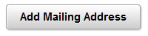

- Enter the new address information
then click the Save button.

Maintaining Personal Phone Numbers

- Click on Personal Detail tile as noted in the “View Your Personal Information” section.
- Click the Contact Details link.

The Contact Details page opens.

- You can modify an existing phone number by clicking on the phone number.
- To delete a phone number, click on the number, click delete button at bottom of the pop up window.
- Click the plus icon to add a new phone number. Then click the Save button.

Reporting Exception Time

Click on the “Report Time” tile

The Timesheet page opens.

Exception time reporters only report exceptions such as sick or vacation. Regular scheduled work days do not need to be entered.

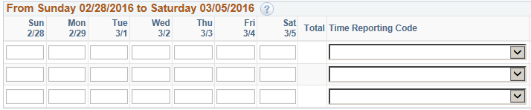

- Select a Time Reporting Code from the dropdown list.

- Enter the amount of hours. Note:
If you used 4 hours sick time, for example, be sure to also record 4 hours REG (regular time) to make the day whole. Total hours must equal your scheduled work day.

Click the submit button

Reporting Hourly Time

Click on the “Report Time” tile

The Timesheet page opens.

- Select REE Time Reporting Code from the dropdown list.
- For each day worked, enter the amount of hours.

Click the submit button

